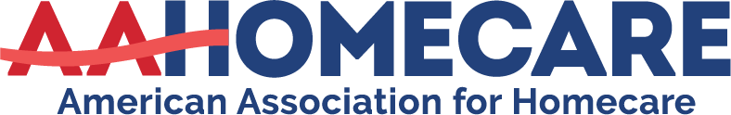

AMERICAN RESCUE PLAN ACT SUMMARY
Signed into law March 11, 2021
Section 9817 of ARPA
10% FMAP Increase for HCBS

https://www.hhs.gov/about/news/2021/05/13/cms-issues-guidance-american-rescue-plan-funding-medicaid-home-and-community-based-services.html

- Intent of Funding
  - Implement or supplement the implementation of activities to enhance, expand, or strengthen Home and Community Based Services
  - Must Supplement, Not Supplant existing state funds spent
  - Strengthen HCBS in response to PHE
  - Increase access to HCBS for Medicaid beneficiaries
  - Adequately protect the HCBS workforce
  - Safeguard financial stability for HCBS providers
  - Accelerate LTSS reform
- Increased FMAP cannot exceed 95%
- States cannot impose stricter eligibility standards
- Preserve covered HCBS services in effect as of 4/1/2021
- Maintain provider payments at a rate NO LESS than those in place as of April 1, 2021
- Appendix C and D are EXAMPLES of programs that can be implemented
- Rate Increases for direct care workers (Page 19-Appendix C and D)
- PPE (Page 19 Appendix C and D)
- Expanding Provider Capacity (Page 23-Appendix C and D)-Self Directed programs
- Telehealth and Technology (Page 23-Appendix C and D)
- Providing Access to Additional Equipment/Devices

